THYMES
CUMBERLAND COUNTY MASTER GARDENERS
AUGUST, 2023

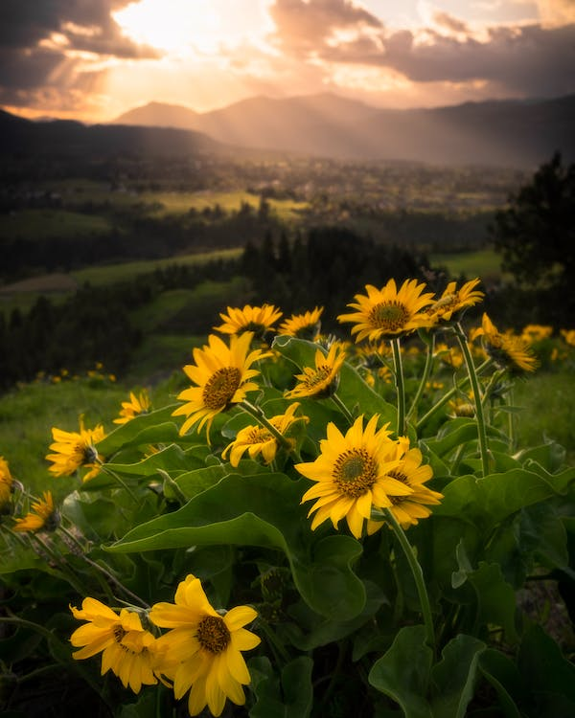
President: Mike Barron
End of Summer
I am one of those people who love summer and hate to see it end, although I won’t miss 90 degree days. Signs like the passing of my sunflowers and the coming of the Fall Gardeners Festival show me that we are on the downward side.
This has been a year of experiments on my property, with some going better than others, and I have learned from each success and failure. I look forward to giving a tour and getting your inputs during the picnic, so please be candid with suggestions. I can use all of the help that I can get.
In the month of September, we will begin the nomination process for officers. The current Board will act as the nominating committee, but we would like to get suggestions from the membership on people with the right skills to perform the duties. If you can’t serve, feel free to volunteer others, anonymously of course.
Current Board members will also be around to help new officers learn what is needed to be successful and offer guidance to those in new positions. The nominations will be communicated in the October meeting, and voting on the nominations will occur in November.
September 5, Member Picnic, begins at 4 pm with supper around 5:30. We will have a great turnout, and the only hiccup would be if it rains. If it rains, our home will not handle a crowd, and we would have to reschedule.
October 3 – Member Meeting @ 1 pm in the Country Store (remember that we are switching to our new schedule of daytime meetings October through March.)

Our annual Fall Festival, the day for Master Gardeners and Plateau Gardens to shine, has arrived. Mums, pumpkins, ice cream, and experts!

Master Gardener Articles
Sue Partch: Dog Days of Summer
When I decided to title my end-of-summer article Dog Days, my first thoughts were about the plants and situations that occur then. But then I wondered, Why is this part of the year called that? Some on-line research, including the Farmer’s Almanac, yielded the following: The term “Dog Days” traditionally refers to the period of hot, humid weather between early July and early September (sources varied concerning the time span) when Sirius, the Dog Star, rises and sets with the sun in the northern hemisphere. Additionally, in Ancient Greece and Rome the Dog Days were believed to be a time of drought, bad luck, and unrest when both men and dogs would be driven crazy by the sweltering heat.

Back to my original article thoughts…There haven’t been many Dog Days this summer. We’ve had quite a bit of rain, even severe storms, with power outages and plant damage. In contrast to droopy, thirsty plants in other Augusts, this year there are plenty of bright, colored blooms to see. Yards have lots of shrubs in pinks and white: Rose of Sharon, hydrangea, crepe myrtle. Flower beds show yellows and oranges with sunflowers and marigolds. Vegetable gardens have tasseled corn and red tomatoes. Farm stands offer cucumbers, squash, tomatoes, berries and more.

The long lasting Queen Anne’s lace still dominates roadsides and fields, but half of it is now curled up into drying seed heads. The blue chicory is also hanging in, but these two stalwarts are now joined by other small tiny white-flowered plants. The Black-eyed Susans and mullien have yellow competitors in primroses, coreopsis, tickseed and several wild sunflowers. A few pinks and purples for contrast are wild sweet pea vines and tall, Joe-Pye weed.

The last haying is happening. Also glimpsed are faint colors here and there in the trees. School slow zones are back and the fair has come and gone. The true sign of summer’s end though is the appearance of goldenrod. Spotted everywhere and the harbinger of the first frost, goldenrod gives six more warm weeks after the first bloom according to folk lore.

Master Gardeners at the Cumberland County Fair: Creative and Colorful

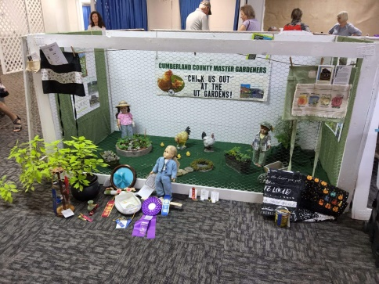
This year, the Master Gardeners increased public awareness by setting up a booth at the Cumberland County Fair. Our thanks to Connie Farley for the idea, registering us, and influencing the booth design. Connie and Sue Partch put together a gardening scene, promoting the Plateau Discovery Gardens. It displayed a flower garden, vegetable garden, small pool, tree patch, and two doll gardeners with gardening tools, along with pictures of PDG, and PDG brochures, held in apron pockets. Plus, the required chicken theme was carried out.

We received $15 for entering; no ribbons, but lots of brochures were distributed.

Other master gardeners also participated as fair workers and exhibitors. Workers included Connie Taylor, Elaine Peters, Glenda Wisdom, and Rhoda Hiller who helped check exhibits in and out. Additional MG participation at the fair included workers and exhibitors.
Workers, including Connie Taylor, Elaine Peters, Glenda Wisdom, and Rhoda Hiller helped check exhibits in and out. Exhibitors won several first, second and third place ribbons and even a best of show. Exhibitors were Connie Taylor with an impressive 11 ribbons out of 13 entries; and Rita Reali, Connie Farley, Elaine Peters and Sue Partch who all won some first place blues.

Pollinators: If You Grow It, They Will Come
Written by Kristi DuBois Photo Credits: David Clark
Most people enjoy watching the pollination antics of beautifully colored butterflies, fuzzy bumblebees,
and comical hummingbirds, but these aren’t the only pollinators. In fact, there are over 200,000 insect
pollinators, including wasps, flies, and moths, and more than 1000 vertebrate pollinators such as birds,
bats, and even lizards. If it weren’t for these pollinators assisting in the reproduction of a wide variety of
flowering plants, local ecosystems would collapse. Humans would lose 1/3 of their crops: almonds,
squash, cherries, blueberries, apples, chocolate and many other important food, fiber, and medicinal
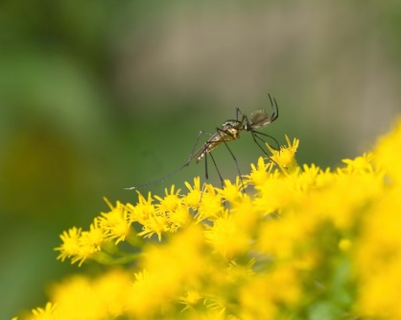
plants (UT PDG).

Midge on goldenrod

Pollinators, however, aren’t thinking about us when they unwittingly deposit pollen on the stigma of a
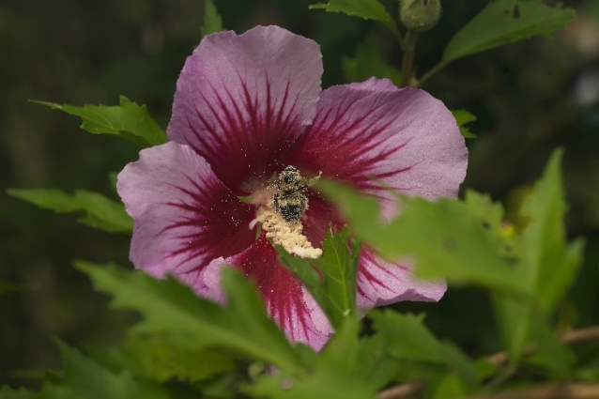
flower, from which it will travel to the flower’s ovary to fertilize an egg and produce a new seed.
Pollinators are after the sweet nectar and the pollen protein and fats of a flower. But while feeding,
they accidentally brush against the pollen of one flower and carry it to the reproductive parts of another
flower, thus initiating the reproduction of another plant. This is one way plant life continues.

Bee covered in pollen on rose of Sharon

Unfortunately, however, many of our pollinators in the U.S. are in trouble because of loss of habitat,
improper use of pesticides, parasites, diseases, and climate change (National Academy of Sciences).
Honeybees, for example, are experiencing the highest death rates ever. The once ubiquitous monarch
butterfly is now rarely seen. Bats are threatened by climate change and the fungus that causes white-
nose syndrome. All this bad news for pollinators can be quite overwhelming. But there are actions that
each individual can take in their own yards and gardens that can collectively add up to positive
outcomes for our native pollinators.
First and foremost, we can stop using pesticides to kill one or two pesky insects like Japanese beetles
while inadvertently killing dozens of needed pollinators as well. Instead, we can plant a wide diversity of
plants so that pests are more likely to take smaller, less harmful nibbles out of many plants rather than
decimating one beloved rose bush, for example. If we must use pesticides, we can use target sprays for
specific pests and spray when fewer pollinators are around, such as when flowers are not blooming
(National Academy of Sciences).
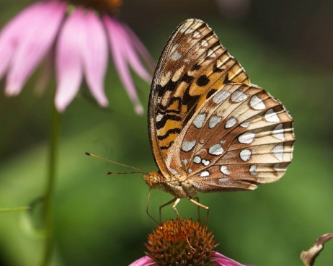

Fritillary butterfly on coneflower

We can make peace with the weeds in our yard, which contrary to popular belief, may not be useless, rather
very important to pollinators. In our yard, for example, we have chosen to let clover interweave with
the grass as a beautiful groundcover that provides much-needed sustenance for bees early in the season
when not a lot of other flowers are blooming. We’ve also left the tiny daisy-like fleabane (Erigeron
annuus) for the tiniest of pollinators in the spring and the towering American burnweed (Erechtites
hieracliifolius) for fall pollinators.

This time of year (late summer/early fall) we can leave the dead flower stalks and seeds of plants such as
herbs and raspberry canes for stem-dwelling bees and other pollinators to hibernate in and eat over the
winter. In the spring we can cut back the flower stalks and leave stem stubble as nest cavities for bee
larvae to develop. We can leave our mulched areas around trees and shrubs with bare soil or thin mulch
for ground-nesting bees which, by the way, are the majority of bees. Rather than retiring our raised beds
for the season, we can plant cover crops like clover or buckwheat to extend the period of pollen and
nectar for pollinators (Tsuruda).
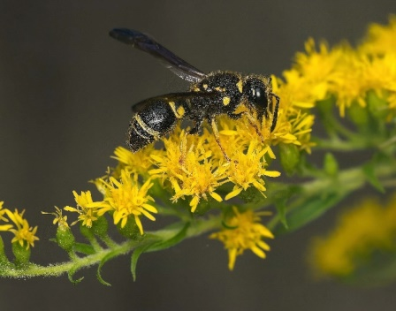

Bee on goldenrod

Fall is also a great time of year to collect seeds of wild pollinator plants. On our unsprayed roadsides and
power line right of ways, there are now a profusion of wildflowers highly attractive to pollinators; plants, such as the stately Joe-Pye weed (Eutrochium spp.), bright goldenrod (Solidago spp.), and cheerful yellow composites like our many Tennessee coreopsis and sunflower species. When the seed heads wither and start to dry, we can collect them in a paper bag, let the seeds drop out, and then plant the seeds in our beds in late fall to overwinter and stratify for the spring.

Finally, early fall is the best time to plant pollinator-loving perennials. To provide a target for pollinators,
we should plant in clusters and plan for continuous bloom throughout the seasons, from early spring to
late fall. Pollinators are attracted to native and non-native flowers alike, but we need to be sure to avoid
invasive plants that will push out our valuable native species (Tsuruda). For example, butterfly bushes
(Buddleja davidii) are definitely a magnet for butterflies, but these Chinese natives can outcompete
native plants that native butterflies need for their caterpillars and eggs. Research has shown
problems even with sterile varieties (Cameron).

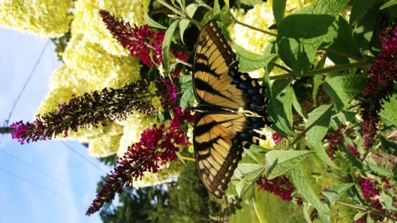

Swallowtail on sterile butterfly bush

It is probably safer to focus on native plants that have co-evolved with their pollinators if we want to be more ecologically sustainable. Fortunately, there are many native perennial pollinator plants that we can plant this autumn to bloom for many years to come.

Butterflies prefer brightly-colored flowers with flat landing platforms such as purple coneflower
(Echinacea purpurea) and clusters of tiny flowers as in the majestic ironweed (Vernonia spp.) and the
showy goldenrod (Solidago spp.).

Bees swarm to sweet-smelling flowers that are white, yellow, blue or
purple (they don’t see red!) such as the native bee balm (Monarda fistulosa) or the mountain mints
(Pycanthemum spp.). Hummingbirds favor red, pink, and orange flowers with tubes for their straw-like
bills. Favorites include members of the agastache and penstemon genera. Moths, flies and bats, on the
other hand, prefer white or pale-colored flowers (Benton County Master Gardeners; National Academy
of Sciences)
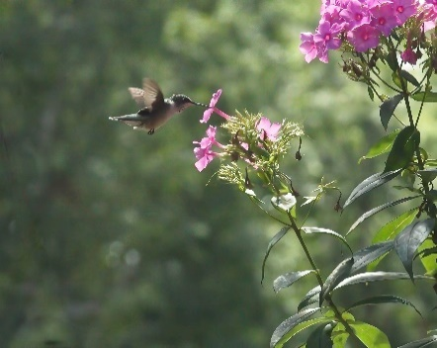

Hummingbird feeding on phlox nectar

It is also critically important for butterflies and moths to plant natives whose leaves are a platform for
eggs and a food source for developing caterpillars. For example, common milkweed (Asclepias syriaca)
and swamp milkweed (Asclepias incarnata) provide critical habitat for the endangered monarch while
the spicebush swallowtail relies on spicebush (Lindera benzoin) and specific native trees to lay their eggs
on.
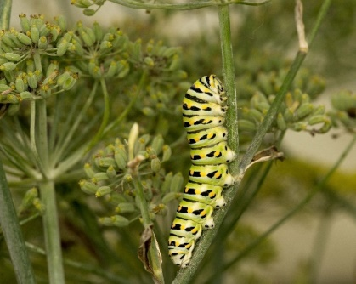

Eastern black swallowtail caterpillar on fennel
Where can we buy native perennial plants? Local nurseries like Landscape Solutions and Dirty Girls are
stocking native plants and will continue to do so if we support this cause. The Obed Watershed
Community Association also sells native plants at local events like the Cumberland County Farmers
Market. We can also drive to nurseries specializing in Tennessee native plants including Tennessee
Naturescapes in Clinton, Reflection Riding Arboretum in Chattanooga, and Overhill Gardens in Vonore.

It’s easy to go to a nursery and impulse buy the latest and showiest plant that we see, but it is more
beneficial for our local environment to do our research and plant species that are pollinator-friendly and
not invasive. Providing habitat for pollinators will not only beautify our yards but also sustain our crops
and local ecosystems for future generations.

For more pollinator plant ideas, see the UT Extension publication Planting for Pollinators in East
Tennessee and visit the UT Plateau Discovery Gardens.

Photos taken at UT Plateau Discovery Garden and the yard of MG Intern Kristi DuBois.

Sources: 1) Benton County Master Gardeners, Oregon, (2018), {Handout} 2) Cameron, Leslie--Master
Gardener of Tennessee, (2018), Are Butterfly Bush Cultivars Labeled as “Sterile” Environmentally
Safer?) 3) National Academy of Sciences, The Truth about the Birds and the Bees based on the 2006
Status of Pollinators in North America 4) Tsuruda, Jennifer, (2023), Pollinators in the Landscape.
{Power Point slides}. University of Tennessee Extension Master Gardeners presentation. 5) University of
Tennessee (Plateau Discovery) Gardens, (2023). {Pollinator fact signs}.

